
Head Teacher: Kas Mohamed
Kepplehills Road, Bucksburn, Aberdeen AB21 9DG
Telephone: 01224 710700 Fax: 01224 715175
Email: BucksburnAcademy@aberdeencity.gov.uk

Dear Parent/Carer

S5 and S6 Parents' Evening

You are invited to school to meet with your child’s teachers at a parents’ evening on
Wednesday 25 November, 2015 starting at 5pm.

From today each pupil will be able to arrange appointments with class teachers, using the
appointment sheet on the reverse of this letter.. Each appointment will be for five minutes and in
order for this system to work this time limit will have to be strictly observed. It will be helpful if
five minute intervals are left between appointments to allow time to move from one teacher to
another. Please note that all appointments will be on the ground floor, in either the Assembly
Hall or Dining Area, which are located to the left as you enter the main entrance of the school.

We hope you are able to attend.

Yours sincerely

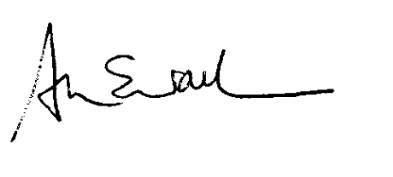
Mrs A Walker
School Support Services Manager

E D U C A T I O N and C H I L D R E N ‘ S S E R V I C E S 

Director: Gayle Gorman

