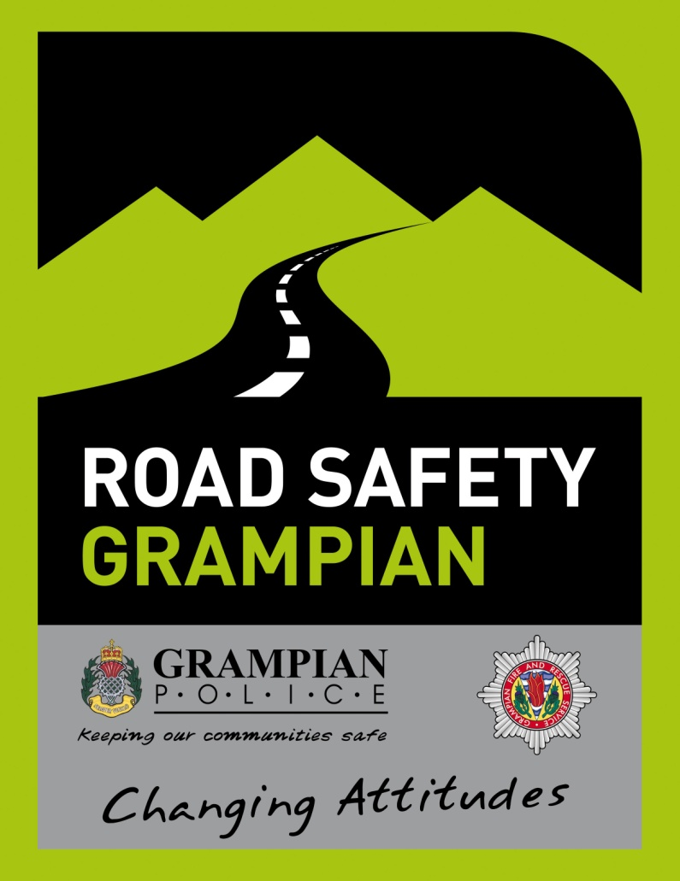

ROAD SAFETY GRAMPIAN

Hi,

As the summer holidays draw near and you start thinking about the warm sunny days ahead, take a moment to think about your safety whilst using the roads.

For some young people, the summer will be full of fun and enjoyment, but unfortunately for others it will be filled with pain and tragedy.

Every year in the Grampian area young people die on our roads needlessly. The majority of these collisions could easily have been avoided if the drivers had shown a more mature attitude to driving and regard for their and other road users safety.

Past collisions have shown the following as the main causes –

Speed- The faster you drive, the less time you have to take in what's happening around you and the greater the distance that is required to bring your vehicle to a stop. It is not clever or impressive to drive at high speed. Other drivers will not be expecting you to be travelling at speed and may misjudge a manoeuvre. Remember, as a young driver you still have limited experience. You only become experienced when you have been driving for many years. You may not live long enough to gain this experience if you drive at high speeds.

Alcohol - Any amount of alcohol consumed will have an adverse effect on your ability to drive. Even a small glass of wine or a half pint of lager will affect your coordination and slow down the thinking process. Do not feel pressured by your friends into having an alcoholic drink if you are driving. One in six of all road deaths are attributed to alcohol. You are the driver, you make the decisions - don't make the wrong one!

Drugs – Illegal substances are known to have a detrimental affect on the body and it's development. Consuming drugs and thereafter getting behind the wheel of a vehicle is complete stupidity. Like alcohol, drugs affect your coordination and thinking process. Even prescribed and over the counter medication can affect your ability to drive, so read the leaflet accompanying it.

Carelessness – Concentrate on your driving at all times. Pay particular attention on the approach to and at junctions. Remember, overtaking is the most dangerous manoeuvre you will make on the road so make sure it is 100% safe before doing so. Don't become distracted by passengers or loud music within the car. A lapse in concentration of a couple of seconds can be disastrous. Be courteous towards other road users and treat them the way you would wish to be treated.

Mobile Telephones - You are four times more likely to crash if you are using a mobile telephone whilst driving. You cannot concentrate fully on your driving and hold a telephone conversation at the same time. No call or text is worth losing your life for. Place your telephones on silent and into the glovebox, this way you will not be tempted to use it. Hands free kits are legal, however they are still a huge distraction and should be avoided whilst driving.

Remember, the human brain isn't fully developed until 25 years of age so already young drivers have a slight disadvantage. Don't risk your and other people's safety further by doing any of the above whilst driving.

Have a great summer and enjoy yourselves, but don't let it be spoiled by carnage and heartache. Be responsible.

Regards,

Road Safety Grampian.

