Bird Survey Report 2011

On the 10th of January 2011 the S4 Environmental Education class spotted 30 starlings, 7 carrion crows, 1 woodpigeon, 20 common seagulls,
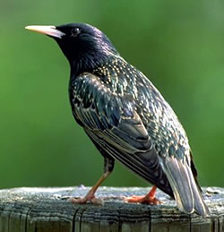
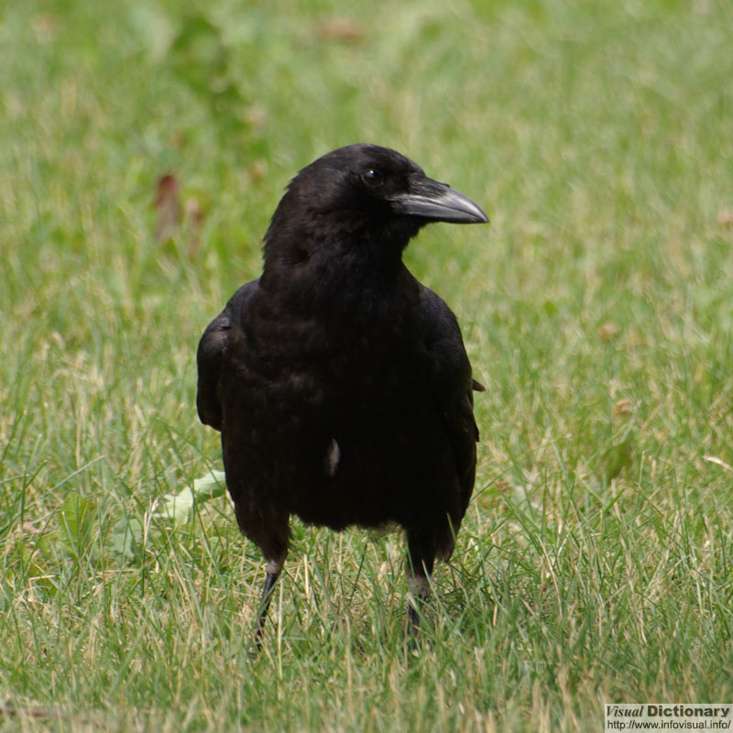
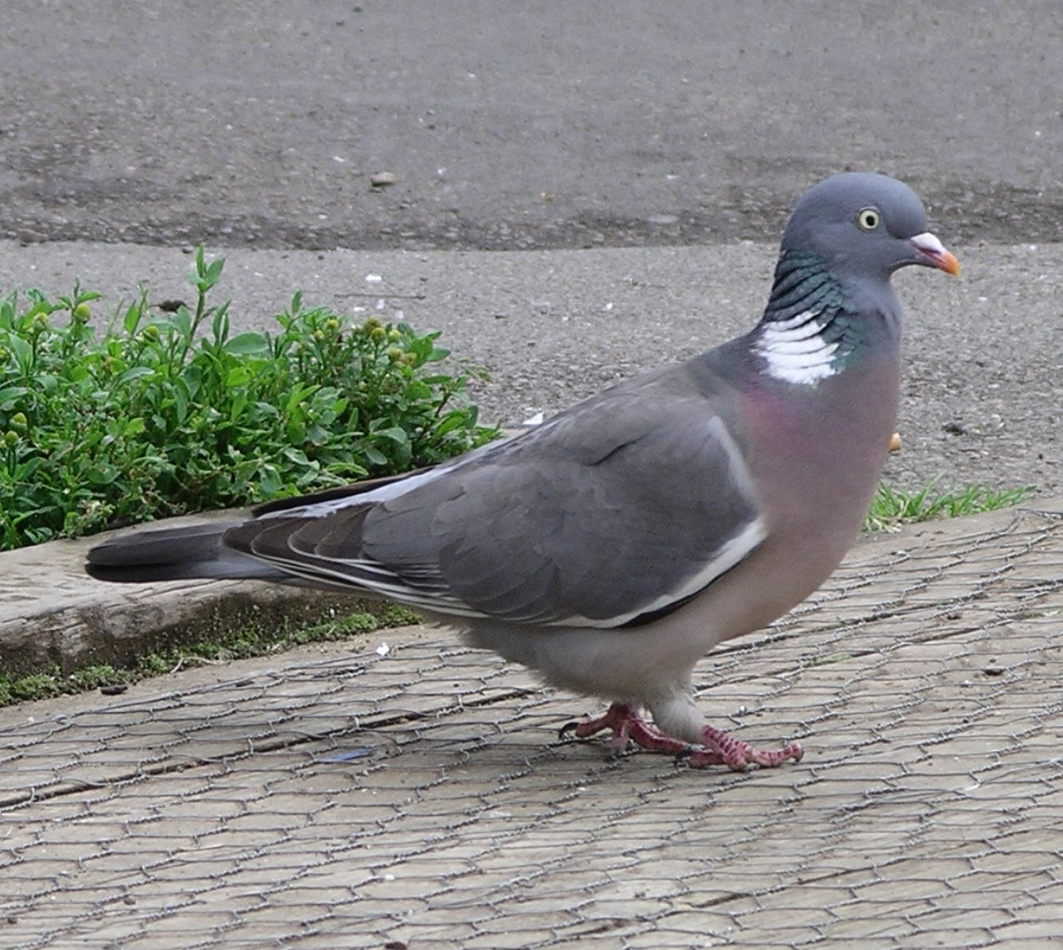
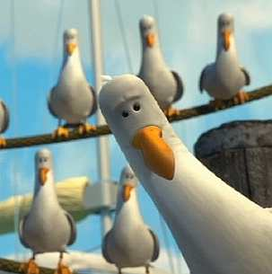

10 black headed gulls and 1 blackbird.
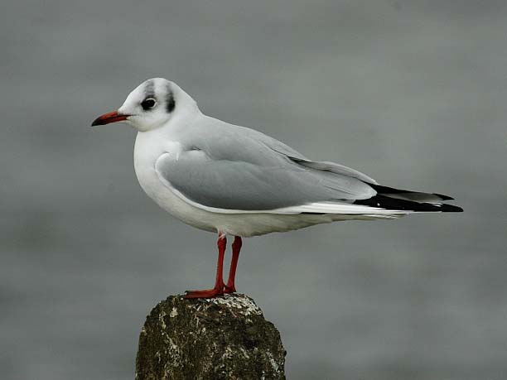
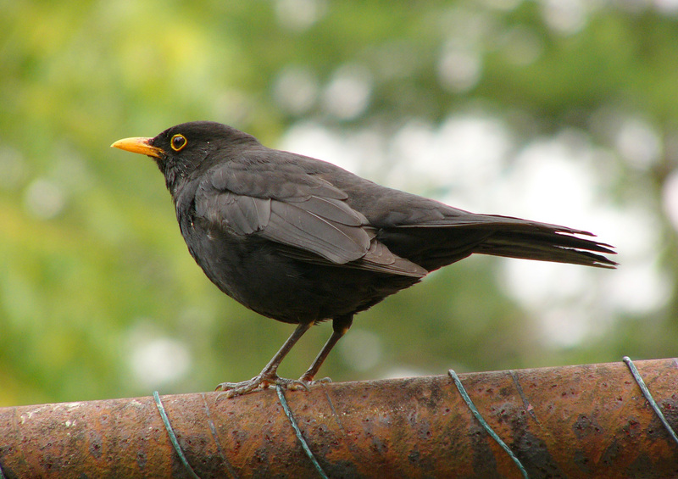

The results will of this and other surveys the class carry out will be passed onto the RSPB as part of their
2011 Schools Birdwatch.

S4 Environmental Education Class

